CS 255 System Design Document
Andrew Brannan
8/15/26

UML Diagrams

UML Use Case Diagram
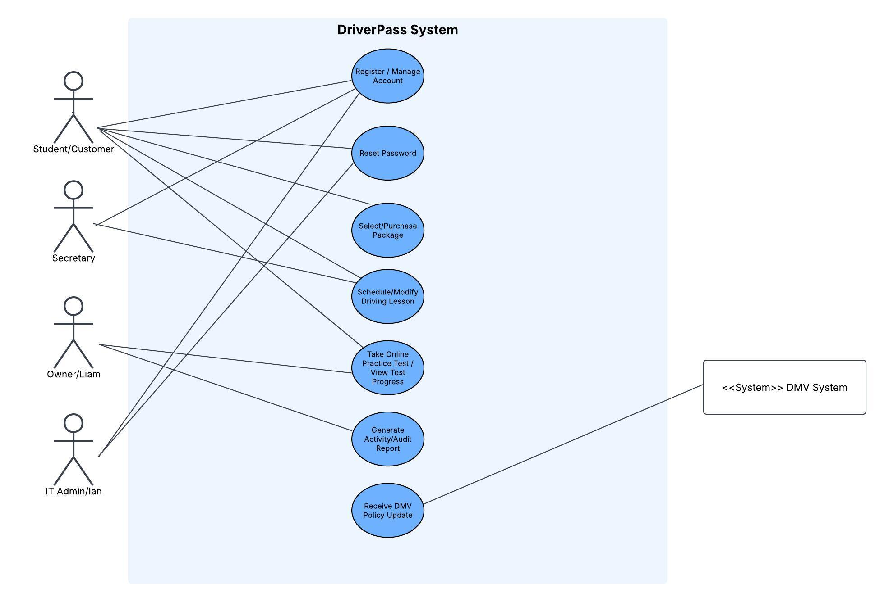

UML Activity Diagrams
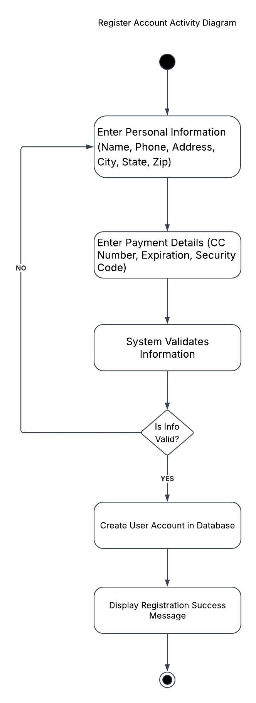
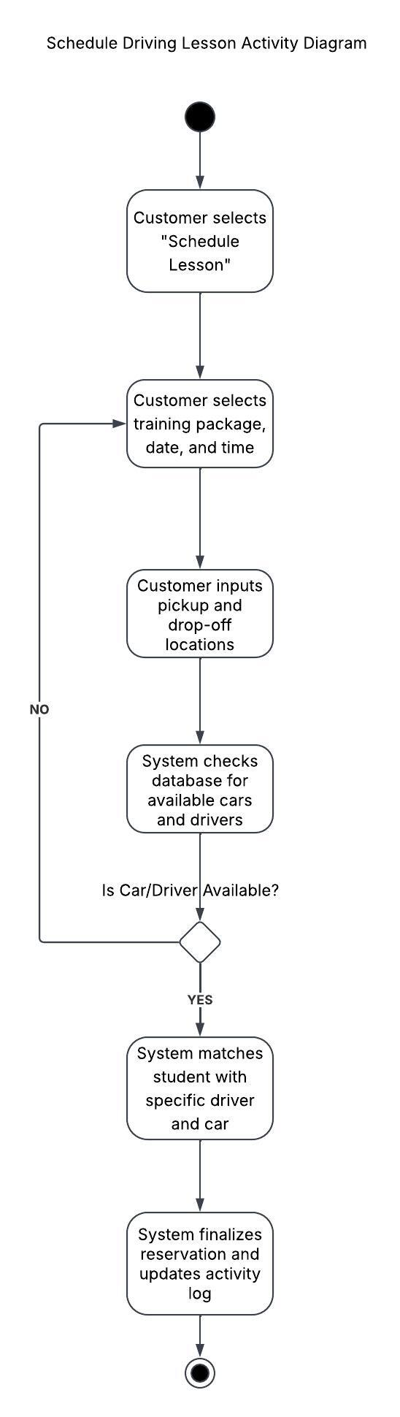

UML Sequence Diagram
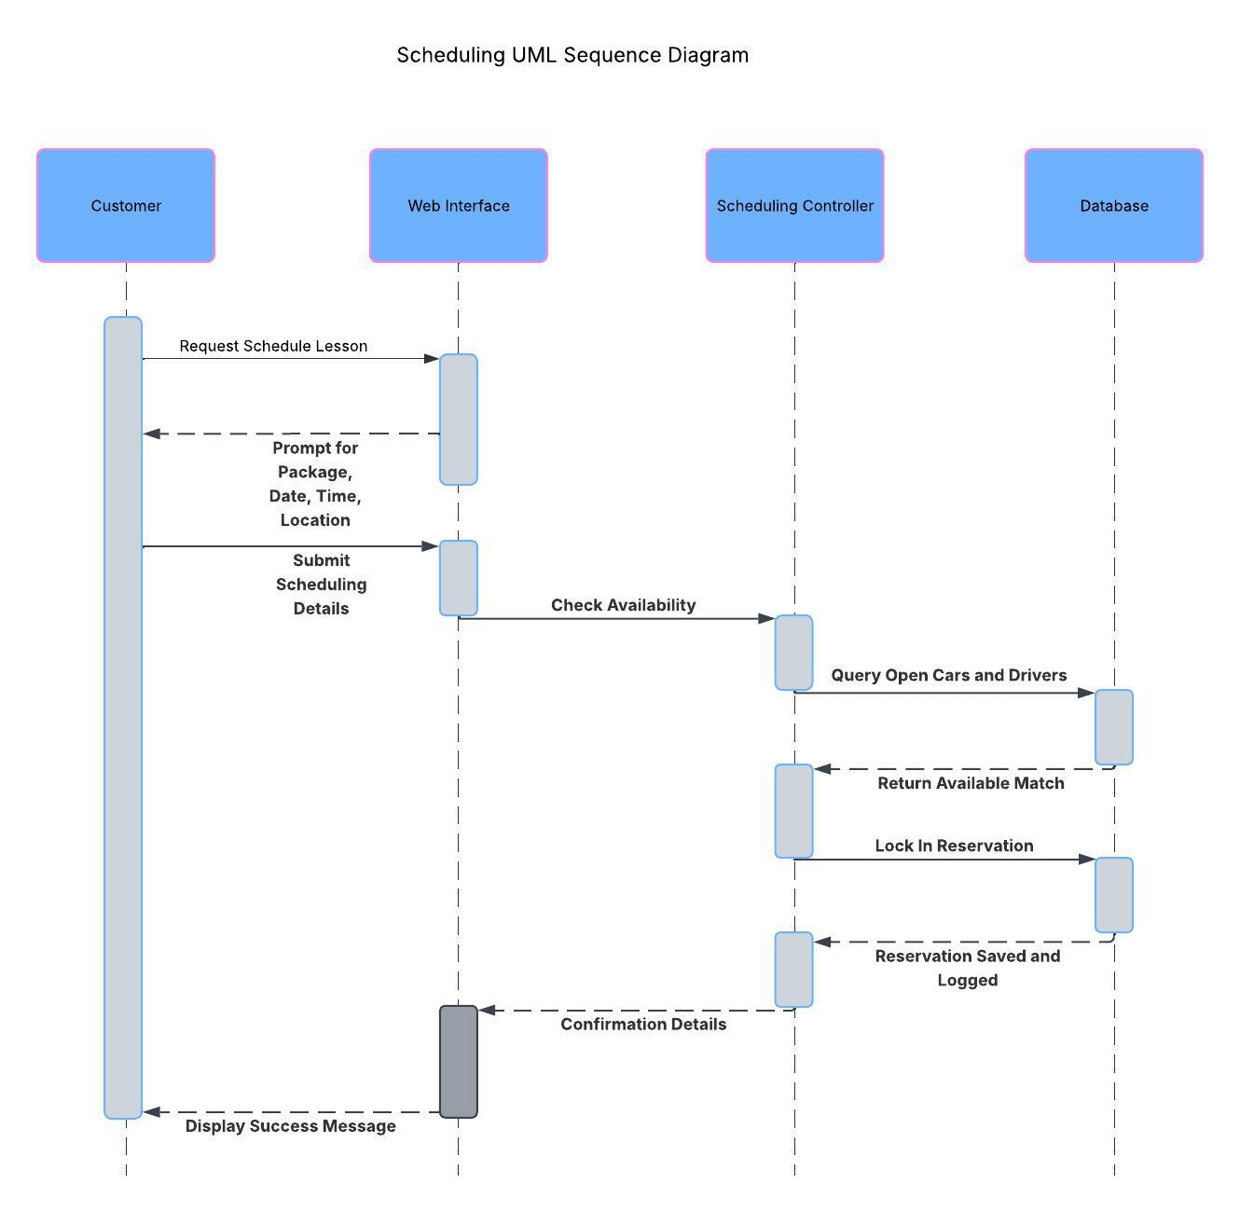

UML Class Diagram
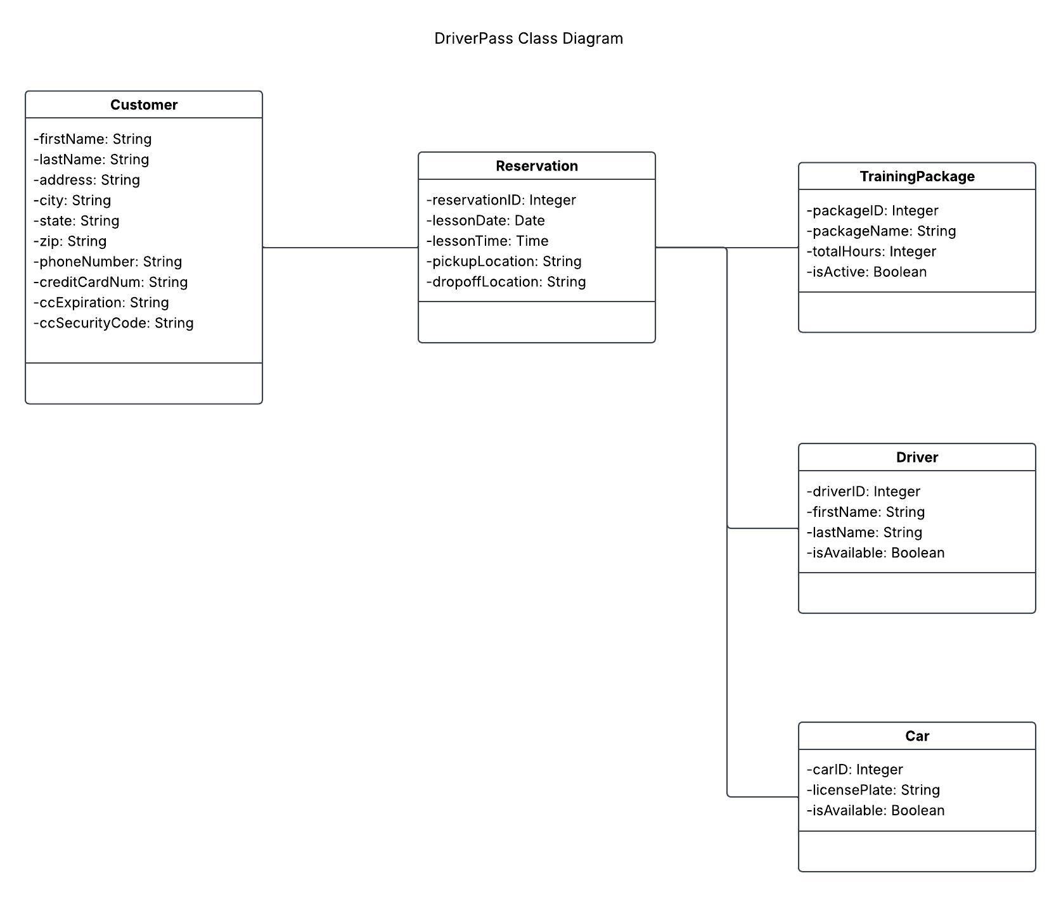

Technical Requirements
We’re building the DriverPass system as a cloud-based web application to keep the technical foundation flexible and secure. Hosting the system on a platform like Amazon Web Services or Microsoft Azure removes the need for physical servers. This handles all automatic data backups so Ian and the IT team do not have to manage local security hardware. Customers and staff will simply access the platform using their PCs and mobile devices.
The software requires a direct connection to the local DMV network. This allows the application to automatically pull in new rules and sample test questions the moment the DMV updates them. We’re also including an export tool. Liam explicitly needs the ability to download system data into Microsoft Excel format so he can work on activity reports at home.
Security is a major priority for the overall architecture. We need a strict access control layer where Ian has full administrative oversight to manage employee accounts, reset passwords, and revoke access for terminated staff. The platform also requires an encrypted payment gateway. This will securely handle customer credit card transactions during registration.

